# C1- S1 – PRACTICE

**LET’s BE BACK TO VUE !!**

## EXERCICE 1

* Enter 2 numbers
* Select the OPERATION to perform
* Click on COMPUTE
* The result corresponding to the OPERATION is displayed

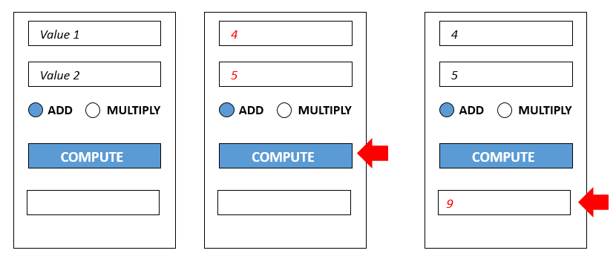

## EXERCICE 2

* Display the list of **student** **scores** for each **topic** in a table
  + If student score is less than 50, display the score in **RED**

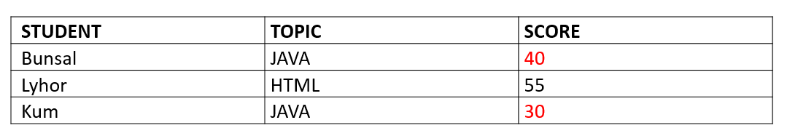

* Create **new score** (student name + topic + score) when button ADD is pressed
  + New score must be added to the table



* Display the AVERAGE of scores related to HTML topic
  + This AVERAGE is updated whenever a new score is added

For example here:

* + 3 scores are related to HTML : 10 , 20, 30
  + So the AVERAGE is (10 + 20 + 30) 3 = 20

